**1. Design and draw UML class diagram to represent an airline reservation system. The system enables the customer to search for airline flight on a specified date and choose a flight based on some details like availability. The customer can reserve a flight or cancel his reservation. The system displays all the flight details such as flight number, name, price and duration of journey.**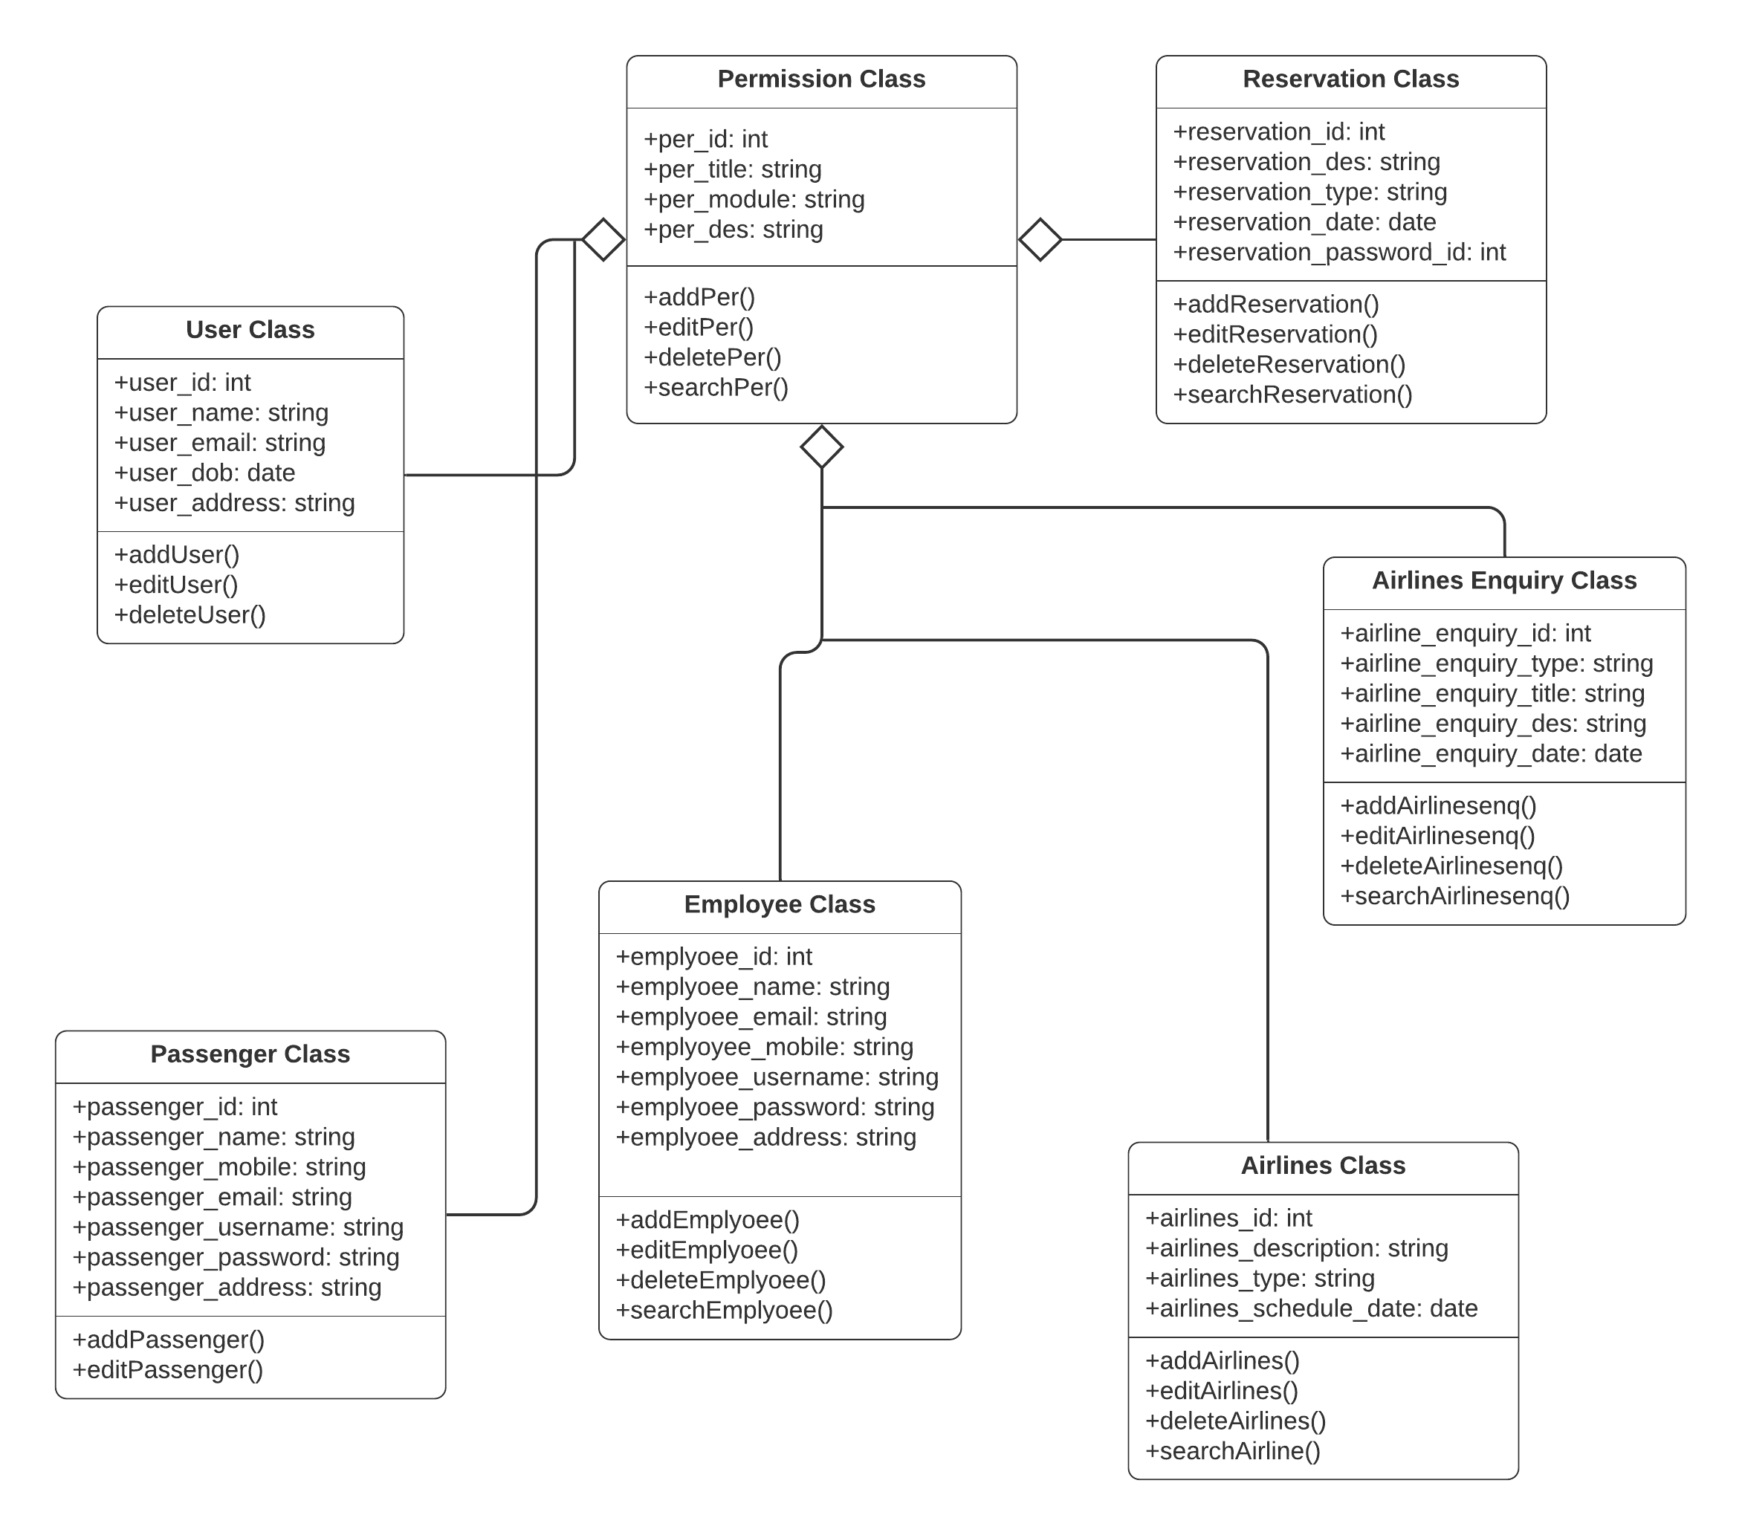

1. **Design and draw UML class diagram with attributes, behaviour, and class relationships for the following scenario.  
     
   In a university there are various departments. A department has a name and is associated to classrooms and offices. An employee working at the university has a unique Id and can be a professor or an instructor. A professor can be a full professor or associate professor, or assistant professor and he/she belongs to a department in the university. Offices and classrooms also have unique IDs and classrooms have fixed number of seats. Also, every employee is assigned an office.**  
   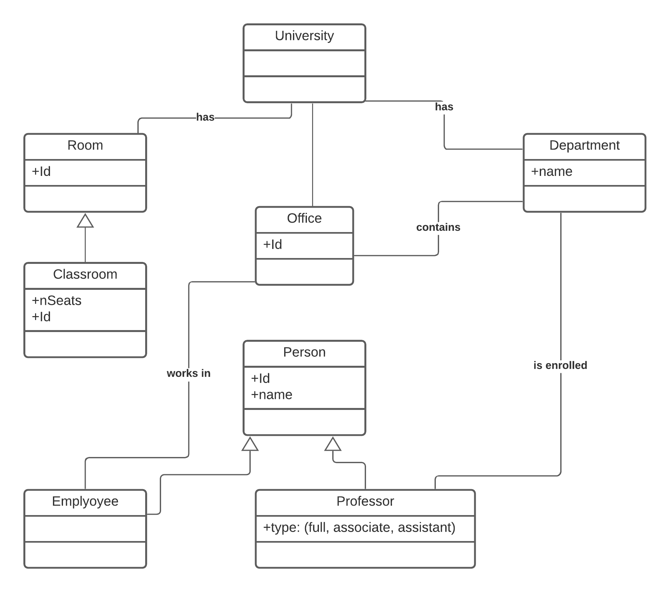

1. **Draw an activity diagram for the given scenario where a student needs to enroll with the university for the given course.**

**Process for student enrolment in the university is as follows:**

* **An applicant wants to enroll in the university.**
* **The applicant hands a filled-out copy of Enrolment Form.**
* **The registrar inspects the forms.**
* **The registrar determines that the forms have been filled out properly.**
* **The registrar informs student to attend in university overview presentation.**
* **The registrar helps the student to enroll in seminars**
* **The registrar asks the student to pay for the initial tuition.**

